**INTERDISCIPLINARY GROUP PROJECT**

**--------------**Semester 2 **--------------**

**PORTFOLIO: PROJECT PORTFOLIO – INTERFACE FOR A&E PATIENT SIMULATION**

**Group Number:**6

**Full Name:**

* Aruna Surapureddy
* Julian Longworth
* Chidubem Onyejemuo
* Pham Vo Ngoc Ngan
* Magnolia Biswas

**Module Name and Code**: UFCFWQ-45-M – Interdisciplinary group project 22sep_1

**Declaration**:

* **I declare that I am the sole author of this work.**
* **I have not copied work from any source (including my own previously submitted work for which credit has been/is due to be awarded at UWE or elsewhere).**
* **I have not shared any versions of my work being submitted with other students.**
* **I have not viewed any versions of the work being submitted by other students.**
* **I have fully acknowledged/referenced all sources of information used.**
* **I am aware that failure to comply with the above may constitute an assessment offence.**

**I. INTRODUCTION**

It is understood that potential outbreaks of epidemics such as COVID-19 and other winter infections could have a major negative influence on hospital service quality, especially the Accident and Emergency Department (A&E Department) is crucial and any errors could result in the loss of human life.  As part of a large project that investigated the factors that have impacted the performance targets of all the UK’s hospitals in general and the Accident and Emergency Department (A&E Department) in particular, I and team members discussed and decided to build the A&E Department simulation model by creating an easy-to-use program on the Tablet. In this program, patients can easily interact with and will enable them to check in as well as stimulate their anticipated waiting time based on a number of factors; for example, which department they are going to be treated by, which hospital they are visiting or whether their attendance was booked in advance. This simulation model is built on the dataset from NHS of previous patients to make predictions about the patient’s visit in the future.

**II. LITERATURE REVIEW**

**1. Model and Simulation**

Simulation is a mature method that has been widely used in many areas such as the manufacturing industry, business, aviation, and healthcare industry for decades.  For more than twenty years, simulation had been utilized to solve healthcare problems in the US and UK. For instance, Pitt (1997) used the State Transition Networks to model patient flows in a hospital. Besides that, Jun et al. (1999) presented a survey of 117 applications of simulation in healthcare clinics. The majority of simulation studies in the healthcare industry have focused on A&E Department (Miller et al., 2004). Previously, there are numerous researchers who attempted to model the A&E Department using mathematical models, analytical or mathematical models are inefficient because they only offer long-term average solutions, which do not help in a hospital’s planning process and frequently lead to impractical outcomes. Therefore, simulation is a helpful tool in this research since it uses the quantitative method to analyse virtual models and the behaviour during a definite duration as well as eliminate non-value-added operations, reveal any potential system bottlenecks, and help identify of ‘optimal’ solution.

Law et al (2000) suggested a systematic approach to conducting a simulation study. The step-by-step approach is illustrated in Figure 1 and listed as follows:

* **Step 1:** Identify the problem and plan the study
* **Step 2**: Collect data and define the model
* **Step 3:** Construct the model
* **Step 4:** Verification
* **Step 5:** Validation
* **Step 6**: Design the experiments
* **Step 7:** Run the experiments
* **Step 8:** Analyse the output results
* **Step 9:** Document, present and use the results.

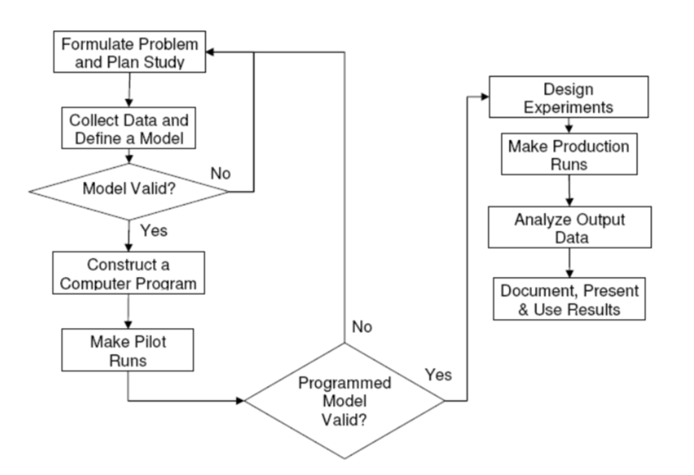

**Figure 1:** Flow of Simulation

**2. Accident and Emergency Department**

1. 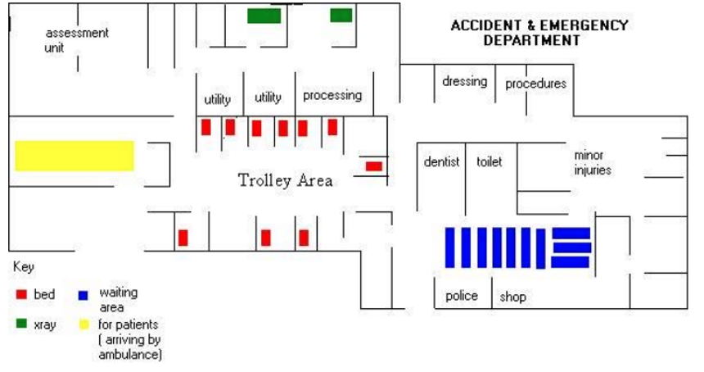***The Accident and Emergency Department’s Layout***

**Figure 2:** Floor Plan of the A&E Department

Figure 2 shows the accident and emergency department’s layout. All patients arrive at the reception desk, where their information is taken down as they wait for triage. During triage, the nurse will record vital signs which are determined through direct and external contact in the triage room. Patients without appointments are classified into such as major A&E, single speciality and another A&E/minor injury unit. For patients who arrive by ambulance, the registration clerk and the triage nurse are called to the trolley area. Here, the nurse will carry out a urine test or ECG, for patients were required. Depending on the patient’s acuity, the doctor will select a folder and call the patient to a treatment room The patient’s need for a blood test and x-rays will subsequently be decided by the medical professionals. The X-ray department receives patients who need to have an X-Ray taken. The patient is brought back into the treatment room after the X-Ray procedure, where the doctor will determine the best course of treatment. If it is decided that the patient needs to be sent to a specialist, he/she will then wait for the specialist in the trolley area. The specialist will be paged in the interim to visit the patient in the trolley area. A nurse must check on a patient every half an hour while they are in the trolley area waiting for a specialist and must let them know how they are doing. The Minors Department, which treats patients with small wounds, is open from nine in the morning until midnight. Nurse practitioners care for the majority of these patients. Depending on their condition, nurses check on the patients in the trolley area every 20 to 30 minutes.

***b.  Causes of Prolonged Waiting Time***

The A&E Department accounts for a significant percentage of a hospital’s admission and handles the most urgent cases of the day, nearly 600,000 cases on a yearly basis. Patients are usually grouped into appointment cases and random walk-ins (Kaukainen, 1986). Moreover, patients are classified into three main types including type I – major A&E, type II – single speciality and type III – other A&E/minor injury unit. It is observed that one of the main problems of simulating the A&E Department in the hospital is that some emergencies are superimposed upon scheduled appointments and so it is very difficult to predict and manage patient arrivals at any point in time. Only 67% of Category III patients were treated within 120 minutes, which was less than the outcomes in the hospital. Furthermore, it is observed that the situation is worsening when doctors are engaged in resuscitation for type I and type II cases. There has been an increase in ambulance calls. It takes place from 8:00 to 9:00, 11:00 to 14:00, 18:00 to 20:00 during the peak. As a result, Levary summarized a plethora of underlying reasons for the delays in the emergency department such as overcrowding during peak hours, delays in diagnostic test results, access to supplies and equipment, adjustments in patient service priority and admission to an inpatient unit that are organized in a fishbone diagram in Figure 3 as below:

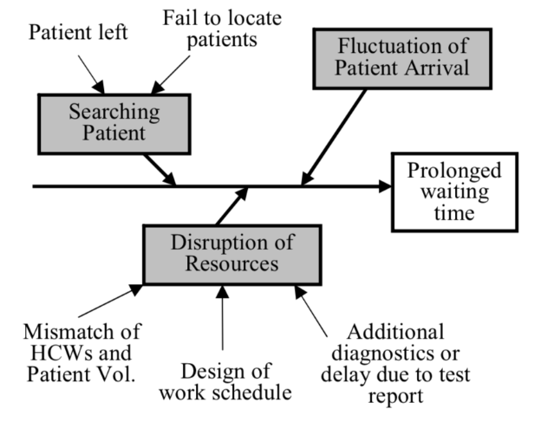

**Figure 3:** Causes of Prolonged Waiting Time

A number of case studies have been performed on A&E Departments. Garcia et al. (1995) suggested utilizing simulation to investigate the potential for a fast track to shorten the length of time in an emergency room. In another simulation study, McGuire (1998) advised using a fast track to reduce the length of stay in the emergency room, adding a patient care coordinator during peak hours, and having an alternative room for hospitalized patients.

**3. Accident and Emergency Department in the United Kingdom**

The UK National Health Service (NHS) has a performance measurement framework which forms part of an improvement regime.  In 1997, the goal of the length of time patients must wait before being seen by a doctor or nurse practitioner was set at 15 minutes. In 2002, the UK Department of Health introduced a new performance indicator that the percentage of patients whose total duration in the A&E Department exceeds 4 hours. When introduced in 2002, there were to be no breaches of the 4-hour A&E target. However, in 2004 and 2005, there was a 2% breach level because some patients will need extended care in the emergency departments for good medical reasons (Department of Health, 2003). However, the 2% relaxation on the target percentage is not sufficient to take the pressure from A&E Departments. Additionally, they also observe that 1 in 8 patients who are subsequently admitted to hospitals are transferred from A&E just before their stay exceeds the 4-hour target. Especially, from 2019 to 2021, the breakdown of Covid-19, there was a 10% breach level.

The project attempts to enhance the operational efficiency of the A&E Department by eliminating all potential blockages and shortening the waiting time to meet the service pledges. The creation of the simulation model can help with process reengineering, facility and resource planning, treatment efficacy evaluation, and clinical workflow decision-making.

**III. METHODOLOGY**

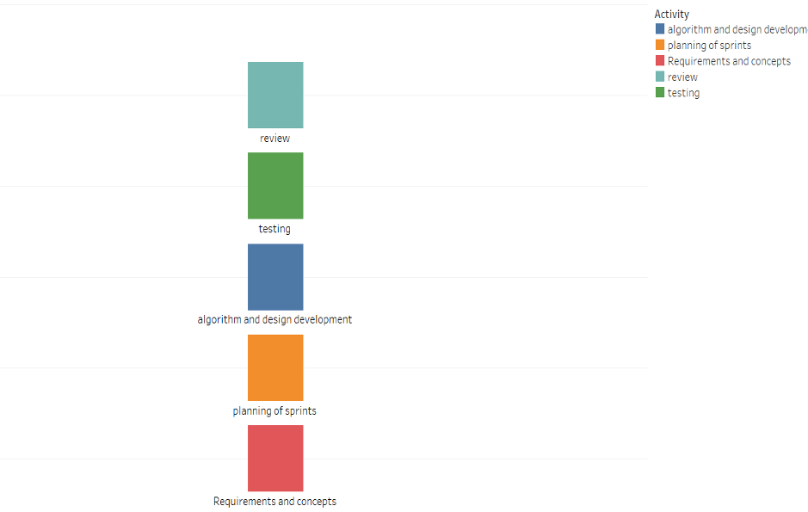The agile methodology that we used helped us monitor parallel workflow and encourages small development and validation, handling the challenges and changes achieved effectively through this model, and providing the option of going back and editing our work after minutes meetings held every week.

**Figure 4:** Agile Methodology.

Before building the model, we created a visual representation of our project schedule by using the Grantt Chart in Tableau Software. For this, we manually created a spreadsheet with task names, start dates, end dates, and time to complete each task, and created a chart that allowed us to monitor regular changes in schedule or progress, which helped us to meet our project deadlines.

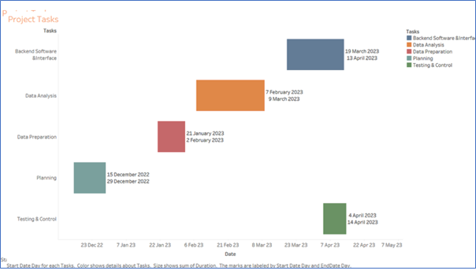

**Figure 5:** Project Tasks by Grant Chart

**1. Data Collection**

We conducted a survey in Bristol via google form with a questionnaire containing a minimal number of questions, namely seven questions, in order to understand how long the NHS chain of hospitals takes to treat emergency patients.

**The link of survey** <https://docs.google.com/forms/d/e/1FAIpQLSeQAuXZvYbxB8xfXI_jLN4lbJqngJWXDOokoMrCIrLg4isrWA/viewform?usp=>

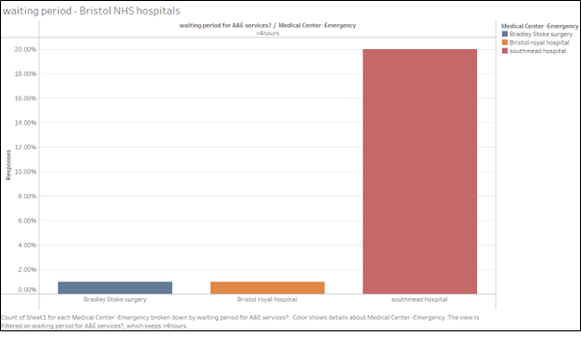

**Figure 6:** Top Three Popular Hospitals in Bristol

Besides collecting the dataset, we have researched some information about the type of departments and the number of beds in three popular in Bristol according to our survey group

|  |  |  |  |  |  |
| --- | --- | --- | --- | --- | --- |
| **Hospital** | **The Type of Departments** | **The Number of Beds** |  |  |  |
| **Southmead Hospital** | 1 Distinct Types of Departments | 1,450 beds |  |  |
| **Bristol Royal Hospital** | **33** Different Types of Departments | 669 beds |  |  |
| **Bradley Stoke Surgery** | **14** Different Types of Departments | 100 beds |  |  |

**NHS Total Attendances >4 Hours**

 The graph below displays a comparison of quarterly waiting times; normally, Q4 has the highest amount of walk-ins due to seasonal fluctuations.

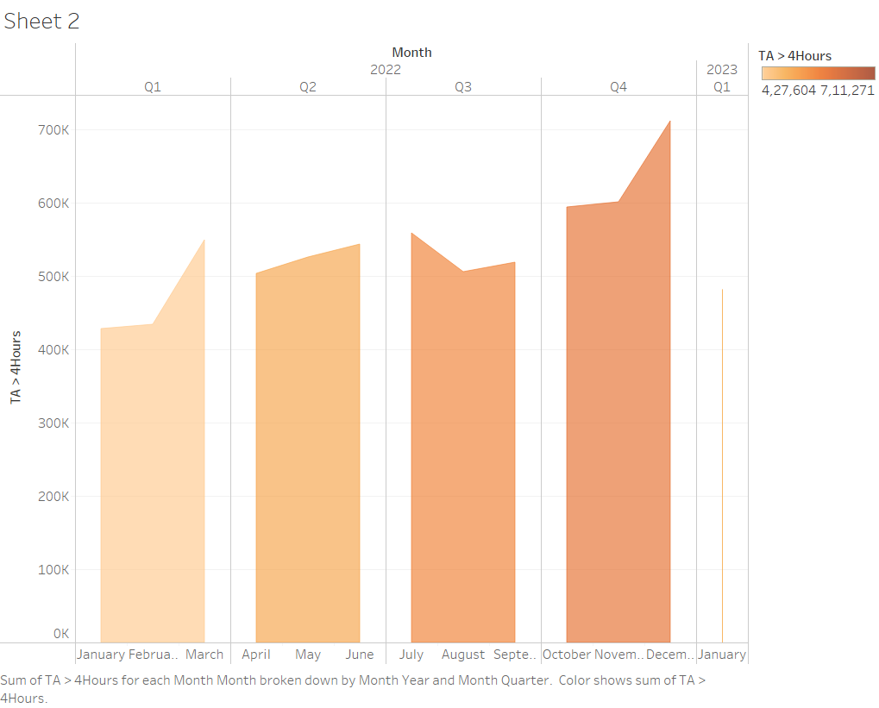

**Figure 7:** NHS Total Attendances Over 4 Hours in 2022

Simultaneously, in order to build model effectively, our group collected the “A&E Attendances and Emergency Admissions” dataset from NHS in one year from January 2022 to January 2023 (***NHS Website:*** <https://www.england.nhs.uk/statistics/statistical-work-areas/ae-waiting-times-and-activity/>)

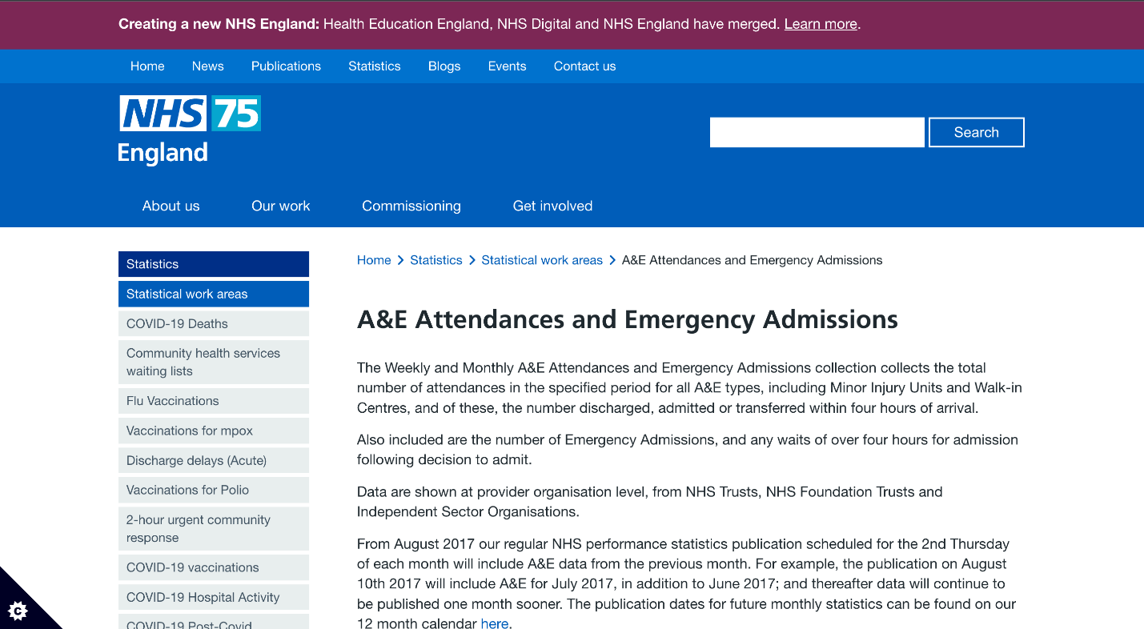

**Figure 8:** NHS75 England Website

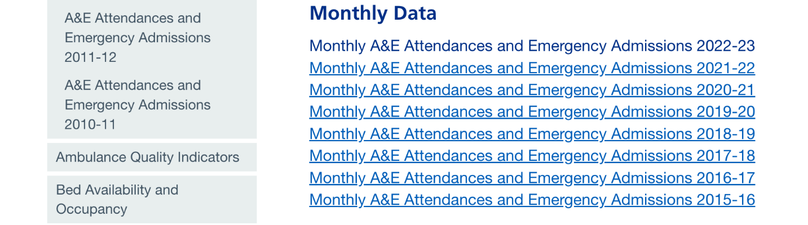

**Figure 9:** All the A&E Attendances and Emergency Admissions datasets from 2015 to 2023

In the first step, we downloaded all the **“Monthly A&E”** CSV files from January 2022 to January 2023. In the second step, we used all data from the **“Non-Booked Data”** sheet and **“Booked Appointments Data”** sheet in every CSV file to synthesise into the final dataset. After that, we changed all the above CSV files that had the same name like **“*-AE-by-provider.CSV”** before coding by Python. In the next step, I utilized the Jupiter Notebook from Anaconda in order to merge 13 CSV files into the final dataset:

Our code is shown below:

**import pandas as pd**

**from glob import glob**

**files = sorted(glob(‘*-2022-AE-by-provider.CSV)**

**files**

**combined_csv = pd.concat((pd.read_csv(file).assign(filenames = file) for file in files), ignore_index = True)**

**combined_csv**

**combined_csv.to_csv(“combined_csv.csv”, index = False, encoding = “utf-8-sig”)**

Our final dataset included **2,637 observations and 40 columns** including:

1. **Code:** The code of hospital that every hospital has a different code.
2. **Region:** The region of the hospital includes the East of England, London, Midlands, North East and York, North West, South West and South East.
3. **Name:** The name of the hospital.
4. **A&E attendances Type 1 Department - Major A&E:** The total number of A&E attendances- Type 1; for example, patients in cardiac arrest (Non-Booked).
5. **A&E attendances Type 2 Departments - Single Specialty:** The total number of A&E attendances - Type 2; for example, eye conditions or dental problems (Non-Booked).
6. **A&E attendances Type 3 Departments - Other A&E/Minor Injury Unit:** The total number of A&E attendances- Type 3; for example, sprains (Non-Booked).
7. **A&E attendances Total attendances:** The total number of A&E attendances - Type 1+2+3 (Non-Booked).
8. **A&E attendance less than 4 hours from arrival to admission, transfer or discharge Type 1 Department - Major A&E:** The total number of patients who have a total time in A&E less than 4 hours from arrival to admission, transfer or discharge – Type 1 (Non-Booked).
9. **A&E attendance less than 4 hours from arrival to admission, transfer or discharge Type 2 Departments - Single Specialty:** The total number of patients who have a total time in A&E less than 4 hours from arrival to admission, transfer or discharge – Type 2 (Non-Booked).
10. **A&E attendances less than 4 hours from arrival to admission, transfer or discharge Type 3 Departments - Other A&E/Minor Injury Unit:** The total number of patients who have a total time in A&E less than 4 hours from arrival to admission, transfer or discharge – Type 3 (Non-Booked).
11. **A&E attendance less than 4 hours from arrival to admission, transfer or discharge Total Attendances < 4 hours:** The total number of patients who have a total time in A&E less than 4 hours from arrival to admission, transfer or discharge – Type 1+2+3 (Non-Booked).
12. **A&E attendances greater than 4 hours from arrival to admission, transfer or discharge - Type 1 Departments - Major A&E:** The total number of patients who have a total time in A&E over 4 hours from arrival to admission, transfer or discharge – Type 1 (Non-Booked).
13. **A&E attendances greater than 4 hours from arrival to admission, transfer or discharge Type 2 Departments - Single Specialty:** The total number of patients who have a total time in A&E over 4 hours from arrival to admission, transfer or discharge – Type 2 (Non-Booked).
14. **A&E attendances greater than 4 hours from arrival to admission, transfer or discharge Type 3 Departments - Other A&E/Minor Injury Unit:** The total number of patients who have a total time in A&E over 4 hours from arrival to admission, transfer or discharge – Type 3 (Non-Booked).
15. **A&E attendances greater than 4 hours from arrival to admission, transfer or discharge Total Attendances > 4 hours:** The total number of patients who have a total time in A&E over 4 hours from arrival to admission, transfer or discharge – Type 1+2+3(Non-Booked).
16. **Percentage of attendances within 4 hours or less (all):** The percentage of patients who have a total time in A&E less than 4 hours from arrival to admission, transfer or discharge – Type 1+2+3 (Non-Booked).
17. **Percentage of attendance within 4 hours or less (type 1):** The percentage of patients who have a total time in A&E less than 4 hours from arrival to admission, transfer or discharge – Type 1 (Non-Booked).
18. **Percentage of attendance within 4 hours or less (type 2):** The percentage of patients who have a total time in A&E less than 4 hours from arrival to admission, transfer or discharge – Type 2 (Non-Booked).
19. **Percentage of attendance within 4 hours less (type 3):** The percentage of patients who have a total time in A&E less than 4 hours from arrival to admission, transfer or discharge – Type 3 (Non-Booked).
20. **Emergency Admissions via Type 1 A&E:** Total number of patients who have waited in A&E for the decision to admit to admission – Type 1 (Non-Booked).
21. **Emergency Admissions via Type 2 A&E:** Total number of patients who have waited in A&E for the decision to admit to admission – Type 2 (Non-Booked).
22. **Emergency Admissions via Type 3 and 4 A&E:** Total number of patients who have waited in A&E for the decision to admit to admission – Type 3 (Non-Booked).
23. **Total Emergency Admissions via A&E:** Total number of patients who have waited in A&E for the decision to admit to admission – Type 1+2+3 (Non-Booked).
24. **Other Emergency admissions (i.e not via A&E):** Total number of patients who have waited not in A&E for the decision to admit to admission (Non-Booked).
25. **Number of patients spending >4 hours from decision to admission to admission:** Total number of patients who have waited 4-12 hours in A&E for the decision to admit to admission – Type 1+2+3 (Non-Booked).
26. **Number of patients spending >12 hours from decision to admission to admission:** Total number of patients who have waited over 12 hours in A&E for the decision to admit to admission – Type 1+2+3 (Non-Booked).
27. **A&E Booked Appointment Attendances Type 1 Department - Major A&E:** The total number of A&E attendances - Type 1; for example, patients in cardiac arrest (Booked appointment).
28. **A&E Booked Appointment Attendances Type 2 Departments - Single Specialty:** The total number of A&E attendances - Type 2; for example, eye conditions or dental problems (Booked appointment).
29. **A&E Booked Appointment Attendances Type 3 Departments - Other A&E/Minor Injury Unit:** The total number of A&E attendances- Type 3; for example, sprains (Booked appointment).
30. **A&E Booked Appointment Attendances Total attendances:** The total number of A&E attendances - Type 1+2+3 (Booked appointment).
31. **A&E Booked Appointments Attendances greater than 4 hours from arrival to admission, transfer or discharge Type 1 Department - Major A&E:** The total number of patients who have a total time in A&E greater than 4 hours from arrival to admission, transfer or discharge – Type 1 (Booked appointment).
32. **A&E Booked Appointments attendances greater than 4 hours from arrival to admission, transfer or discharge Type 2 Departments - Single Specialty:** The total number of patients who have a total time in A&E greater than 4 hours from arrival to admission, transfer or discharge – Type 2 (Booked appointment).
33. **A&E Booked Appointments attendances greater than 4 hours from arrival to admission, transfer or discharge Type 3 Departments - Other A&E/Minor Injury Unit:** The total number of patients who have a total time in A&E greater than 4 hours from arrival to admission, transfer or discharge – Type 3 (Booked appointment).
34. **A&E Booked Appointments attendances greater than 4 hours from arrival to admission, transfer or discharge Booked Appointment Attendances > 4 hours:** The total number of patients who have a total time in A&E greater than 4 hours from arrival to admission, transfer or discharge – Type 1+2+3 (Booked appointment).
35. **A&E Booked Appointments Performance Percentage in 4 hours or less (all) (Booked Appointments Only):** The percentage of patients who have a total time in A&E less than 4 hours from arrival to admission, transfer or discharge – Type 1+2+3 (Booked appointment).
36. **A&E Booked Appointments Performance Percentage in 4 hours or less (type 1) (Booked Appointments Only):** The percentage of patients who have a total time in A&E less than 4 hours from arrival to admission, transfer or discharge – Type 1 (Booked appointment).
37. **A&E Booked Appointments Performance Percentage in 4 hours or less (type 2) (Booked Appointments Only):** The percentage of patients who have a total time in A&E less than 4 hours from arrival to admission, transfer or discharge – Type 2 (Booked appointment).
38. **A&E Booked Appointments Performance Percentage in 4 hours or less (type 3) (Booked Appointments Only):** The percentage of patients who have a total time in A&E less than 4 hours from arrival to admission, transfer or discharge – Type 3 (Booked appointment).
39. **A&E Booked Appointments Performance Percentage in 4 hours or less (All types excluding Booked Appointments):** The percentage of patients who have a total time in A&E less than 4 hours from arrival to admission, transfer or discharge – Type 1+2+3 (Excluding Booked appointment).
40. **A&E Booked Appointments Performance Percentage in 4 hours or less (All types including Booked Appointments):** The percentage of patients who have a total time in A&E less than 4 hours from arrival to admission, transfer or discharge – Type 1+2+3 (Including Booked appointment)

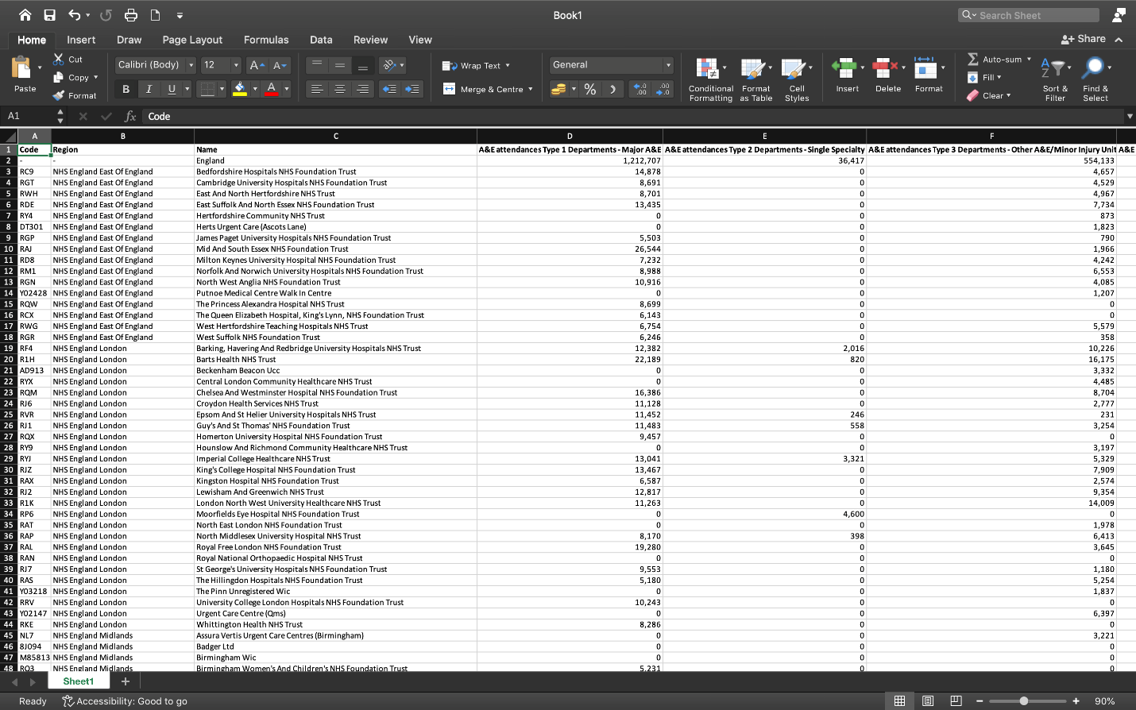

**Figure 10:** Final Dataset

As this dataset is very large, we decided to focus on only the hospitals in South West England. Using this dataset alongside the data for NHS staff members, we generated a linear model to predict the waiting times that a patient would experience. To generate the model, we used R to create a new dataframe that contained the relevant information about each recorded visit, with each row representing a single patient's visit to A&E. The first few rows of this dataframe are shown below:

**"Month","Type_1","Type_2","Type_3","Wait_Time","Booked","HCHS_Doctors","Nurses","Scientific","Support"**

**"Jan",0,0,0,2,0,97,1107,557,1484**

**"Jan",0,0,0,2,0,97,1107,557,1484**

**"Jan",0,0,0,2,0,97,1107,557,1484**

**"Jan",0,0,0,2,0,97,1107,557,1484**

The columns of this dataframe are:

1. Month - The month that the visit took place.
2. Type_1 - '1' if the visit is known to have been to a type 1 department, '0' otherwise.
3. Type_2 - '1' if the visit is known to have been to a type 2 department, '0' otherwise.
4. Type_3 - '1' if the visit is known to have been to a type 3 department, '0' otherwise.
5. Wait_Time - Length of time the patient waited for. Set to the midpoint of the range of values the patient could have waited for. If no upper bound is given, this is set to the lower bound.
6. Booked - '1' if the patient booked their visit ahead of time, '0' otherwise.
7. HCHS_Doctors - The number of HCHS doctors at the hospital the patient visited (Full Time Equivalent).
8. Nurses - The number of nurses & health visitors at the hospital the patient visited (Full Time Equivalent).
9. Scientific - The number of scientific, therapeutic & technical staff at the hospital the patient visited (Full Time Equivalent).
10. Support - The number of support to clinical staff at the hospital the patient visited (Full Time Equivalent).

The code used to generate this dataframe is shown below:

**library(readr)**

**library(ggplot2)**

**library(corrplot)**

**library(data.table)**

**library(glmnet)**

**library(coefplot)**

**library(data.table)**

**data_frame = read_csv("../data/final_dataset.csv")**

**data_frame = subset(data_frame, select = -c(24,25,40,41,43:52))**

**data_frame = data_frame[1:2447,]**

**#data_frame = data_frame[data_frame$Code %in% c('RVJ','QUY','RA7'),]**

**data_frame = data_frame[data_frame$Region ==  'NHS England South West',]**

**for (i in 1:nrow(data_frame)) {**

**if (data_frame$filename[i] == '012022-AE-by-provider.csv') {**

**data_frame$filename[i] = 'Jan'**

**} else if (data_frame$filename[i] == '022022-AE-by-provider.csv') {**

**data_frame$filename[i] = 'Feb'**

**} else if (data_frame$filename[i] == '032022-AE-by-provider.csv') {**

**data_frame$filename[i] = 'Mar'**

**} else if (data_frame$filename[i] == '042022-AE-by-provider.csv') {**

**data_frame$filename[i] = 'Apr'**

**} else if (data_frame$filename[i] == '052022-AE-by-provider.csv') {**

**data_frame$filename[i] = 'May'**

**} else if (data_frame$filename[i] == '062022-AE-by-provider.csv') {**

**data_frame$filename[i] = 'Jun'**

**} else if (data_frame$filename[i] == '072022-AE-by-provider.csv') {**

**data_frame$filename[i] = 'Jul'**

**} else if (data_frame$filename[i] == '082022-AE-by-provider.csv') {**

**data_frame$filename[i] = 'Aug'**

**} else if (data_frame$filename[i] == '092022-AE-by-provider.csv') {**

**data_frame$filename[i] = 'Sep'**

**} else if (data_frame$filename[i] == '102022-AE-by-provider.csv') {**

**data_frame$filename[i] = 'Oct'**

**} else if (data_frame$filename[i] == '112022-AE-by-provider.csv') {**

**data_frame$filename[i] = 'Nov'**

**} else if (data_frame$filename[i] == '122022-AE-by-provider.csv') {**

**data_frame$filename[i] = 'Dec'**

**}**

**}**

**colnames(data_frame)[4:40] = c("T1 Unbooked",**

**"T2 Unbooked",**

**"T3 Unbooked",**

**"All Unbooked",**

**"T1 Unbooked <4",**

**"T2 Unbooked <4",**

**"T3 Unbooked <4",**

**"All Unbooked <4",**

**"T1 Unbooked >4",**

**"T2 Unbooked >4",**

**"T3 Unbooked >4",**

**"All Unbooked >4",**

**"All Unbooked % <4",**

**"T1 Unbooked % <4",**

**"T2 Unbooked % <4",**

**"T3 Unbooked % <4",**

**"T1 Emergency",**

**"T2 Emergency",**

**"T3 Emergency",**

**"All Emergency",**

**"Emergency >4",**

**"Emergency >12",**

**"T1 Booked",**

**"T2 Booked",**

**"T3 Booked",**

**"All Booked",**

**"T1 Booked >4",**

**"T2 Booked >4",**

**"T3 Booked >4",**

**"All Booked >4",**

**"All Booked % <4",**

**"T1 Booked % <4",**

**"T2 Booked % <4",**

**"T3 Booked % <4",**

**"Month")**

**data_frame$`T1 Unbooked <4` = gsub(",","",data_frame$`T1 Unbooked <4`)**

**data_frame$`T2 Unbooked <4` = gsub(",","",data_frame$`T2 Unbooked <4`)**

**data_frame$`T3 Unbooked <4` = gsub(",","",data_frame$`T3 Unbooked <4`)**

**data_frame$`All Unbooked <4` = gsub(",","",data_frame$`All Unbooked <4`)**

**data_frame$`T1 Unbooked >4` = gsub(",","",data_frame$`T1 Unbooked >4`)**

**data_frame$`T2 Unbooked >4` = gsub(",","",data_frame$`T2 Unbooked >4`)**

**data_frame$`T3 Unbooked >4` = gsub(",","",data_frame$`T3 Unbooked >4`)**

**data_frame$`All Unbooked >4` = gsub(",","",data_frame$`All Unbooked >4`)**

**hosp_stats = read_csv("../data/Hospital Stats.csv")**

**hosp_stats = hosp_stats[52:86,]**

**hosp_stats = subset(hosp_stats, select = -c(1:5,34:37))**

**hosp_stats = hosp_stats[!is.na(hosp_stats$`Organisation code`),]**

**hosp_stats$`HCHS Doctors` = gsub(",","",hosp_stats$`HCHS Doctors`)**

**hosp_stats$`Support to clinical staff` = gsub(",","",hosp_stats$`Support to clinical staff`)**

**size = sum(data_frame$`All Unbooked`) + sum(data_frame$`All Booked`) + sum(data_frame$`All Emergency`)**

**new_frame = data.table (Month = rep("",size),**

**Type_1 = rep(0,size),**

**Type_2 = rep(0,size),**

**Type_3 = rep(0,size),**

**Wait_Time = rep(0,size),**

**Booked = rep(0,size),**

**HCHS_Doctors = rep(0,size),**

**Nurses = rep(0,size),**

**Scientific = rep(0,size),**

**Support = rep(0,size)**

**)**

**next_row = 1**

**for (i in 1:nrow(data_frame)) {**

**print(i)**

**if (data_frame$Code[i] != '-' && nrow(hosp_stats[hosp_stats$`Organisation code` == data_frame$Code[i],]) == 1 &&**

**hosp_stats[hosp_stats$`Organisation code` == data_frame$Code[i],]$`HCHS Doctors` != '-' &&**

**hosp_stats[hosp_stats$`Organisation code` == data_frame$Code[i],]$`Nurses & health visitors` != '-' &&**

**hosp_stats[hosp_stats$`Organisation code` == data_frame$Code[i],]$`Scientific, therapeutic & technical staff` != '-' &&**

**hosp_stats[hosp_stats$`Organisation code` == data_frame$Code[i],]$`Support to clinical staff` != '-') {**

**if (data_frame$`T1 Unbooked <4`[i] != '-') {**

**for (j in seq_len(data_frame$`T1 Unbooked <4`[i])) {**

**new_frame[next_row, names(new_frame) :=**

**list(data_frame$Month[i],**

**1,**

**0,**

**0,**

**2,**

**0,**

**as.numeric(hosp_stats[hosp_stats$`Organisation code` == data_frame$Code[i],]$`HCHS Doctors`),**

**as.numeric(hosp_stats[hosp_stats$`Organisation code` == data_frame$Code[i],]$`Nurses & health visitors`),**

**as.numeric(hosp_stats[hosp_stats$`Organisation code` == data_frame$Code[i],]$`Scientific, therapeutic & technical staff`),**

**as.numeric(hosp_stats[hosp_stats$`Organisation code` == data_frame$Code[i],]$`Support to clinical staff`))]**

**next_row = next_row + 1**

**}**

**}**

**if (data_frame$`T2 Unbooked <4`[i] != '-') {**

**for (j in seq_len(data_frame$`T2 Unbooked <4`[i])) {**

**new_frame[next_row, names(new_frame) :=**

**list(data_frame$Month[i],**

**0,**

**1,**

**0,**

**2,**

**0,**

**as.numeric(hosp_stats[hosp_stats$`Organisation code` == data_frame$Code[i],]$`HCHS Doctors`),**

**as.numeric(hosp_stats[hosp_stats$`Organisation code` == data_frame$Code[i],]$`Nurses & health visitors`),**

**as.numeric(hosp_stats[hosp_stats$`Organisation code` == data_frame$Code[i],]$`Scientific, therapeutic & technical staff`),**

**as.numeric(hosp_stats[hosp_stats$`Organisation code` == data_frame$Code[i],]$`Support to clinical staff`))]**

**next_row = next_row + 1**

**}**

**}**

**if (data_frame$`T3 Unbooked <4`[i] != '-') {**

**for (j in seq_len(data_frame$`T3 Unbooked <4`[i])) {**

**new_frame[next_row, names(new_frame) :=**

**list(data_frame$Month[i],**

**0,**

**0,**

**1,**

**2,**

**0,**

**as.numeric(hosp_stats[hosp_stats$`Organisation code` == data_frame$Code[i],]$`HCHS Doctors`),**

**as.numeric(hosp_stats[hosp_stats$`Organisation code` == data_frame$Code[i],]$`Nurses & health visitors`),**

**as.numeric(hosp_stats[hosp_stats$`Organisation code` == data_frame$Code[i],]$`Scientific, therapeutic & technical staff`),**

**as.numeric(hosp_stats[hosp_stats$`Organisation code` == data_frame$Code[i],]$`Support to clinical staff`))]**

**next_row = next_row + 1**

**}**

**}**

**if (data_frame$`T1 Unbooked >4`[i] != '-') {**

**for (j in seq_len(data_frame$`T1 Unbooked >4`[i])) {**

**new_frame[next_row, names(new_frame) :=**

**list(data_frame$Month[i],**

**1,**

**0,**

**0,**

**4,**

**0,**

**as.numeric(hosp_stats[hosp_stats$`Organisation code` == data_frame$Code[i],]$`HCHS Doctors`),**

**as.numeric(hosp_stats[hosp_stats$`Organisation code` == data_frame$Code[i],]$`Nurses & health visitors`),**

**as.numeric(hosp_stats[hosp_stats$`Organisation code` == data_frame$Code[i],]$`Scientific, therapeutic & technical staff`),**

**as.numeric(hosp_stats[hosp_stats$`Organisation code` == data_frame$Code[i],]$`Support to clinical staff`))]**

**next_row = next_row + 1**

**}**

**}**

**if (data_frame$`T2 Unbooked >4`[i] != '-') {**

**for (j in seq_len(data_frame$`T2 Unbooked >4`[i])) {**

**new_frame[next_row, names(new_frame) :=**

**list(data_frame$Month[i],**

**0,**

**1,**

**0,**

**4,**

**0,**

**as.numeric(hosp_stats[hosp_stats$`Organisation code` == data_frame$Code[i],]$`HCHS Doctors`),**

**as.numeric(hosp_stats[hosp_stats$`Organisation code` == data_frame$Code[i],]$`Nurses & health visitors`),**

**as.numeric(hosp_stats[hosp_stats$`Organisation code` == data_frame$Code[i],]$`Scientific, therapeutic & technical staff`),**

**as.numeric(hosp_stats[hosp_stats$`Organisation code` == data_frame$Code[i],]$`Support to clinical staff`))]**

**next_row = next_row + 1**

**}**

**}**

**if (data_frame$`T3 Unbooked >4`[i] != '-') {**

**for (j in seq_len(data_frame$`T3 Unbooked >4`[i])) {**

**new_frame[next_row, names(new_frame) :=**

**list(data_frame$Month[i],**

**0,**

**0,**

**1,**

**4,**

**0,**

**as.numeric(hosp_stats[hosp_stats$`Organisation code` == data_frame$Code[i],]$`HCHS Doctors`),**

**as.numeric(hosp_stats[hosp_stats$`Organisation code` == data_frame$Code[i],]$`Nurses & health visitors`),**

**as.numeric(hosp_stats[hosp_stats$`Organisation code` == data_frame$Code[i],]$`Scientific, therapeutic & technical staff`),**

**as.numeric(hosp_stats[hosp_stats$`Organisation code` == data_frame$Code[i],]$`Support to clinical staff`))]**

**next_row = next_row + 1**

**}**

**}**

**if (data_frame$`T1 Booked >4`[i] != '-') {**

**for (j in seq_len(data_frame$`T1 Booked >4`[i])) {**

**new_frame[next_row, names(new_frame) :=**

**list(data_frame$Month[i],**

**1,**

**0,**

**0,**

**4,**

**1,**

**as.numeric(hosp_stats[hosp_stats$`Organisation code` == data_frame$Code[i],]$`HCHS Doctors`),**

**as.numeric(hosp_stats[hosp_stats$`Organisation code` == data_frame$Code[i],]$`Nurses & health visitors`),**

**as.numeric(hosp_stats[hosp_stats$`Organisation code` == data_frame$Code[i],]$`Scientific, therapeutic & technical staff`),**

**as.numeric(hosp_stats[hosp_stats$`Organisation code` == data_frame$Code[i],]$`Support to clinical staff`))]**

**next_row = next_row + 1**

**}**

**}**

**if (data_frame$`T2 Booked >4`[i] != '-') {**

**for (j in seq_len(data_frame$`T2 Booked >4`[i])) {**

**new_frame[next_row, names(new_frame) :=**

**list(data_frame$Month[i],**

**0,**

**1,**

**0,**

**4,**

**1,**

**as.numeric(hosp_stats[hosp_stats$`Organisation code` == data_frame$Code[i],]$`HCHS Doctors`),**

**as.numeric(hosp_stats[hosp_stats$`Organisation code` == data_frame$Code[i],]$`Nurses & health visitors`),**

**as.numeric(hosp_stats[hosp_stats$`Organisation code` == data_frame$Code[i],]$`Scientific, therapeutic & technical staff`),**

**as.numeric(hosp_stats[hosp_stats$`Organisation code` == data_frame$Code[i],]$`Support to clinical staff`))]**

**next_row = next_row + 1**

**}**

**}**

**if (data_frame$`T3 Booked >4`[i] != '-') {**

**for (j in seq_len(data_frame$`T3 Booked >4`[i])) {**

**new_frame[next_row, names(new_frame) :=**

**list(data_frame$Month[i],**

**0,**

**0,**

**1,**

**4,**

**1,**

**as.numeric(hosp_stats[hosp_stats$`Organisation code` == data_frame$Code[i],]$`HCHS Doctors`),**

**as.numeric(hosp_stats[hosp_stats$`Organisation code` == data_frame$Code[i],]$`Nurses & health visitors`),**

**as.numeric(hosp_stats[hosp_stats$`Organisation code` == data_frame$Code[i],]$`Scientific, therapeutic & technical staff`),**

**as.numeric(hosp_stats[hosp_stats$`Organisation code` == data_frame$Code[i],]$`Support to clinical staff`))]**

**next_row = next_row + 1**

**}**

**}**

**if (data_frame$`T1 Booked`[i] != '-' & data_frame$`T1 Booked >4`[i] != '-') {**

**for (j in seq_len(as.numeric(data_frame$`T1 Booked`[i]) - as.numeric(data_frame$`T1 Booked >4`[i]))) {**

**new_frame[next_row, names(new_frame) :=**

**list(data_frame$Month[i],**

**1,**

**0,**

**0,**

**2,**

**1,**

**as.numeric(hosp_stats[hosp_stats$`Organisation code` == data_frame$Code[i],]$`HCHS Doctors`),**

**as.numeric(hosp_stats[hosp_stats$`Organisation code` == data_frame$Code[i],]$`Nurses & health visitors`),**

**as.numeric(hosp_stats[hosp_stats$`Organisation code` == data_frame$Code[i],]$`Scientific, therapeutic & technical staff`),**

**as.numeric(hosp_stats[hosp_stats$`Organisation code` == data_frame$Code[i],]$`Support to clinical staff`))]**

**next_row = next_row + 1**

**}**

**}**

**if (data_frame$`T2 Booked`[i] != '-' & data_frame$`T2 Booked >4`[i] != '-') {**

**for (j in seq_len(as.numeric(data_frame$`T2 Booked`[i]) - as.numeric(data_frame$`T2 Booked >4`[i]))) {**

**new_frame[next_row, names(new_frame) :=**

**list(data_frame$Month[i],**

**0,**

**1,**

**0,**

**2,**

**1,**

**as.numeric(hosp_stats[hosp_stats$`Organisation code` == data_frame$Code[i],]$`HCHS Doctors`),**

**as.numeric(hosp_stats[hosp_stats$`Organisation code` == data_frame$Code[i],]$`Nurses & health visitors`),**

**as.numeric(hosp_stats[hosp_stats$`Organisation code` == data_frame$Code[i],]$`Scientific, therapeutic & technical staff`),**

**as.numeric(hosp_stats[hosp_stats$`Organisation code` == data_frame$Code[i],]$`Support to clinical staff`))]**

**next_row = next_row + 1**

**}**

**}**

**if (data_frame$`T3 Booked`[i] != '-' & data_frame$`T3 Booked >4`[i] != '-') {**

**for (j in seq_len(as.numeric(data_frame$`T3 Booked`[i]) - as.numeric(data_frame$`T3 Booked >4`[i]))) {**

**new_frame[next_row, names(new_frame) :=**

**list(data_frame$Month[i],**

**0,**

**0,**

**1,**

**2,**

**1,**

**as.numeric(hosp_stats[hosp_stats$`Organisation code` == data_frame$Code[i],]$`HCHS Doctors`),**

**as.numeric(hosp_stats[hosp_stats$`Organisation code` == data_frame$Code[i],]$`Nurses & health visitors`),**

**as.numeric(hosp_stats[hosp_stats$`Organisation code` == data_frame$Code[i],]$`Scientific, therapeutic & technical staff`),**

**as.numeric(hosp_stats[hosp_stats$`Organisation code` == data_frame$Code[i],]$`Support to clinical staff`))]**

**next_row = next_row + 1**

**}**

**}**

**if (data_frame$`Emergency >12`[i] != '-') {**

**for (j in seq_len(data_frame$`Emergency >12`[i])) {**

**new_frame[next_row, names(new_frame) :=**

**list(data_frame$Month[i],**

**0,**

**0,**

**0,**

**12,**

**0,**

**as.numeric(hosp_stats[hosp_stats$`Organisation code` == data_frame$Code[i],]$`HCHS Doctors`),**

**as.numeric(hosp_stats[hosp_stats$`Organisation code` == data_frame$Code[i],]$`Nurses & health visitors`),**

**as.numeric(hosp_stats[hosp_stats$`Organisation code` == data_frame$Code[i],]$`Scientific, therapeutic & technical staff`),**

**as.numeric(hosp_stats[hosp_stats$`Organisation code` == data_frame$Code[i],]$`Support to clinical staff`))]**

**next_row = next_row + 1**

**}**

**}**

**if (data_frame$`All Emergency`[i] != '-' & data_frame$`Emergency >4`[i] != '-') {**

**for (j in seq_len(as.numeric(data_frame$`All Emergency`[i]) - as.numeric(data_frame$`Emergency >4`[i]))) {**

**new_frame[next_row, names(new_frame) :=**

**list(data_frame$Month[i],**

**0,**

**0,**

**0,**

**2,**

**0,**

**as.numeric(hosp_stats[hosp_stats$`Organisation code` == data_frame$Code[i],]$`HCHS Doctors`),**

**as.numeric(hosp_stats[hosp_stats$`Organisation code` == data_frame$Code[i],]$`Nurses & health visitors`),**

**as.numeric(hosp_stats[hosp_stats$`Organisation code` == data_frame$Code[i],]$`Scientific, therapeutic & technical staff`),**

**as.numeric(hosp_stats[hosp_stats$`Organisation code` == data_frame$Code[i],]$`Support to clinical staff`))]**

**next_row = next_row + 1**

**}**

**}**

**if (data_frame$`Emergency >4`[i] != '-' & data_frame$`Emergency >12`[i] != '-') {**

**for (j in seq_len(as.numeric(data_frame$`Emergency >4`[i]) - as.numeric(data_frame$`Emergency >12`[i]))) {**

**new_frame[next_row, names(new_frame) :=**

**list(data_frame$Month[i],**

**0,**

**0,**

**0,**

**8,**

**0,**

**as.numeric(hosp_stats[hosp_stats$`Organisation code` == data_frame$Code[i],]$`HCHS Doctors`),**

**as.numeric(hosp_stats[hosp_stats$`Organisation code` == data_frame$Code[i],]$`Nurses & health visitors`),**

**as.numeric(hosp_stats[hosp_stats$`Organisation code` == data_frame$Code[i],]$`Scientific, therapeutic & technical staff`),**

**as.numeric(hosp_stats[hosp_stats$`Organisation code` == data_frame$Code[i],]$`Support to clinical staff`))]**

**next_row = next_row + 1**

**}**

**}**

**}**

**}**

**new_frame = new_frame[new_frame$Month != "",]**

**write.csv(new_frame, "../data/expanded dataset SWE.csv", row.names = FALSE)**

Once the dataset was created, we used the lasso method to generate a linear model to predict the waiting times of patients.

We decided to use a linear model, as when displaying the relationships between variables on a scatter plot, the relationships seems to follow an approximate linear distribution. The scatter plots for the relevant variables are shown below.

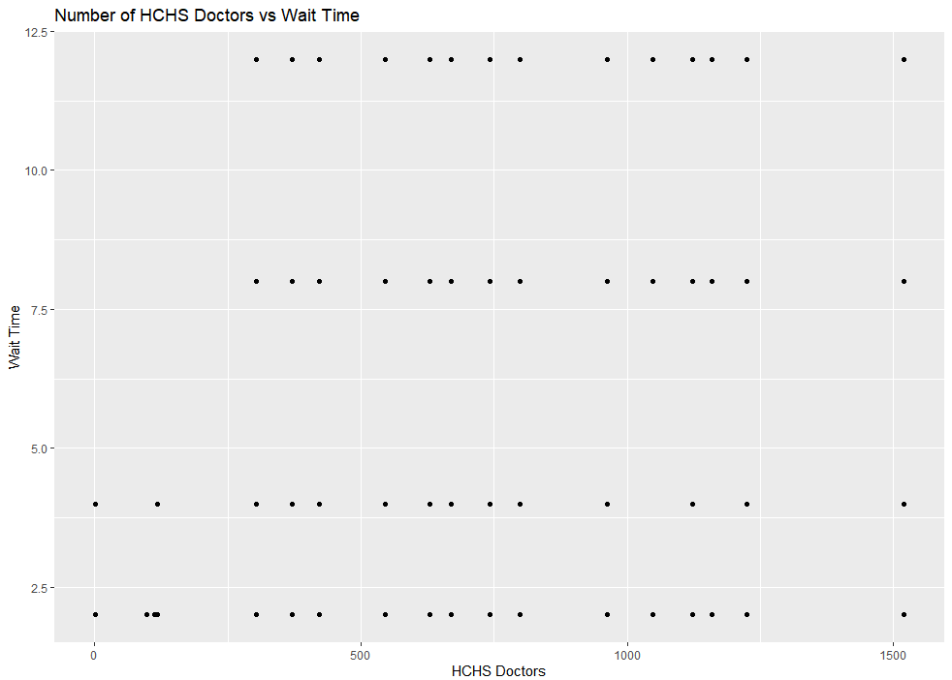

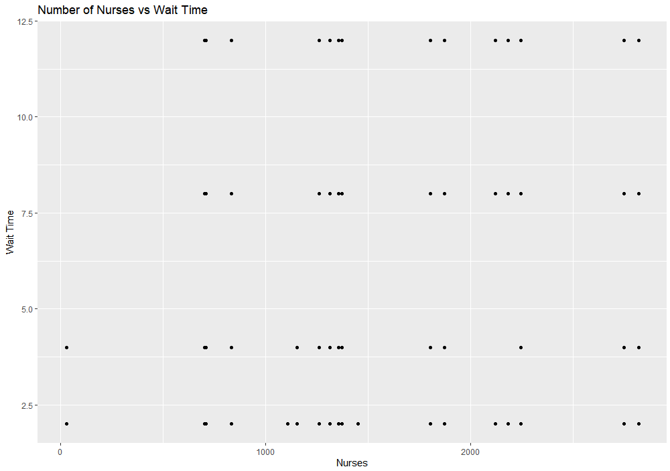**Figure 11:** Number of HCHS Doctors Versus Wait Time

**Figure 12:** Number of Nurses Versus Wait Time

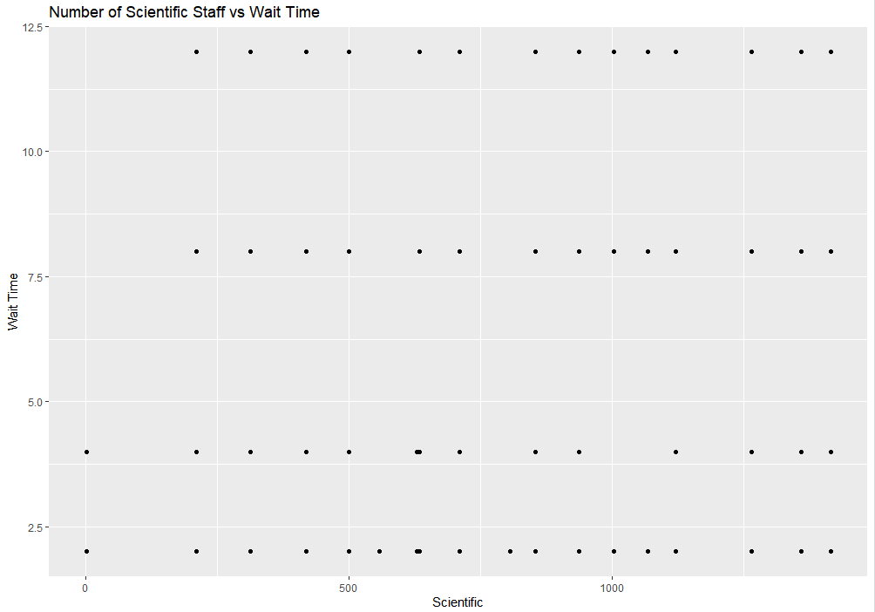

**Figure 13:** Number of Scientific Staff Versus Wait Time

As the Wait_Time variable is only a rough estimate of the actual time that each patient spent waiting, we do not expected this model to have a high R-squared value. In addition, the Wait_Time variable is set to its lower bound if we do not know the upper bound, so the estimates generated by this model will likely be a bit lower than they should. This is not a big issue, as the model will only be used for rough predictions for customers.

The code that was used to generate and test the model is shown below:

**new_frame = read_csv("../data/expanded dataset SWE.csv")**

**# split dataset into training and test datasets.**

**set.seed(42)**

**train_index = sample(seq_along(new_frame$Wait_Time), ceiling(length(new_frame$Wait_Time)/2))**

**df_train = new_frame[train_index,]**

**df_test = new_frame[-train_index,]**

**# uses lasso to determine which variables to include in the model**

**y_train = df_train$Wait_Time**

**x_train = makeX(df_train[, c('Type_1', 'Type_2', 'Type_3', 'Booked', 'HCHS_Doctors', 'Nurses', 'Scientific', 'Support')], na.impute = TRUE)**

**model_train = glmnet(x_train, y_train, alpha = 1)**

**cv_train = cv.glmnet(x_train, y_train, alpha = 1)**

**cv_train**

**extract.coef(cv_train, lambda = "lambda.min")**

**extract.coef(cv_train, lambda = "lambda.1se")**

**plot(cv_train)**

**# creates a linear model using the variables identified and tests it**

**model_final = lm(Wait_Time ~ Type_1 + Type_2 + Type_3 + HCHS_Doctors + Nurses + Scientific, data = df_train)**

**summary(model_final)**

**yhat_test <- predict(model_final, df_test)**

**y_test <- df_test$Wait_Time**

**R_squared_test <- cor(yhat_test,y_test, use = "complete.obs")^2**

**cat("R Squared Test:", R_squared_test)**

The dataset was split into a training dataset and a testing dataset. This was done to allow us to test the model after it was completed. Displaying the variable cv_train, we saw that lambda.min and lambda.1se has very similar values for SE, at 0.009617 and 0.009589 respectively. As a result, we decided to use lambda.1se, as it uses fewer nonzero variables. The variables that this method identified were Type_1, Type_2, Type_3, HCHS_Doctors, Nurses, and Scientific. These variables were then used to generate a model. When tested, the model show a low R-squared value of 0.1858593. This is not surprising, as there are many other factors that could affect how long a patient spends waiting beyond what was included in these datasets. However, all of the variables used have low values for Pr(>|t|). This suggests that these factors do have a meaningful impact on the length of time that patients spend waiting. The coefficients for the model are shown below:

|  |  |  |  |  |
| --- | --- | --- | --- | --- |
|  | Estimate | Std. Error | t value | Pr(>|t|) |
| Intercept | 4.279e+00 | 6.438e-03 | 664.66 | <2e-16 |
| Type_1 | -1.648e+00 | 4.725e-03 | -348.81 | <2e-16 |
| Type_2 | -2.577e+00 | 1.615e-02 | -159.58 | <2e-16 |
| Type_3 | -2.416e+00 | 5.814e-03 | -415.49 | <2e-16 |
| HCHS_Doctors | 5.782e-04 | 1.141e-05 | 50.69 | <2e-16 |
| Nurses | -6.409e-04 | 1.070e-05 | -59.92 | <2e-16 |
| Scientific | 9.844e-04 | 1.552e-05 | 63.45 | <2e-16 |

**IV. THE USER INTERFACE DESIGN FOR THE MODULE SIMULATION**

The User interface design for the mobile application was designed using the Figma tool.

This interface was created with a process that puts in mind the intended users of the mobile application.

The identification of both the primary and secondary users who are the health workers, hospital managers and policy decision makers in the health sector was the first step in creating this design interface, the design also laid emphasis on the characteristics of the users and the user groups instead of just the individuals.

The environment in which the users of the mobile application will be used also played a role in the design and its features. The mobile application is designed to be used in a hospital’s emergency department.

This design presents a specification for a proposed new system, the application is designed to store information that includes the name of the hospital, type of emergency and information on the hospital department that handled the emergency case or where the case was transferred to and records the time that the client spent in the Accident and Emergency Department.

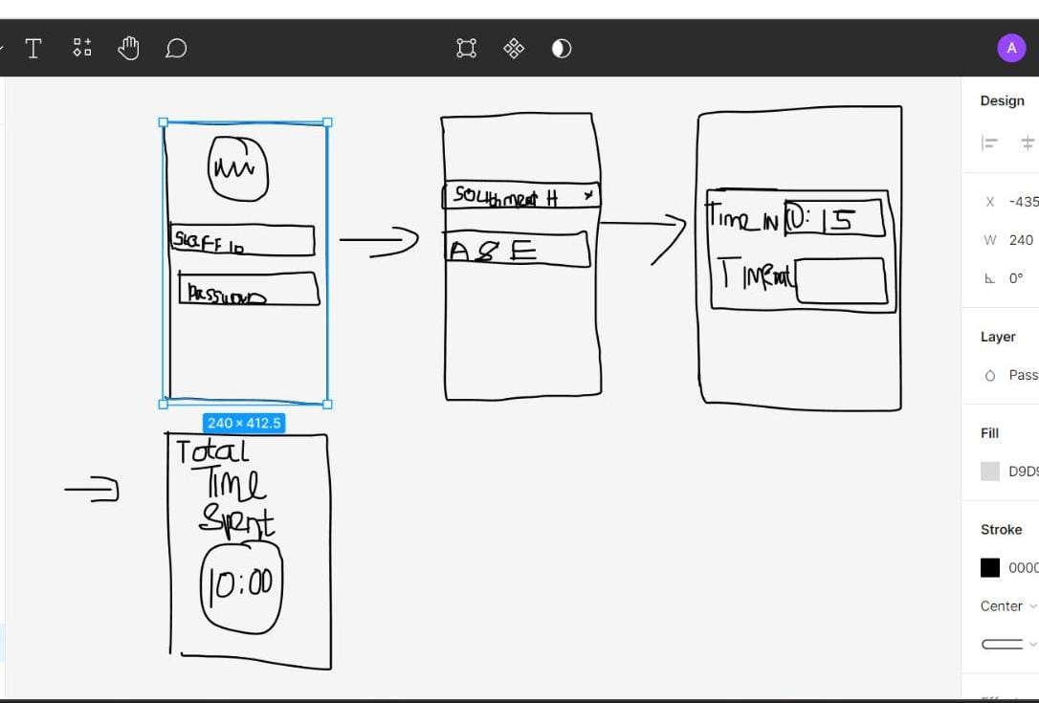

The prototype above was first designed and shown to team members for suggestion and recommendation after which a page showing the type of emergency was included in the hi-fidelity design as shown below –



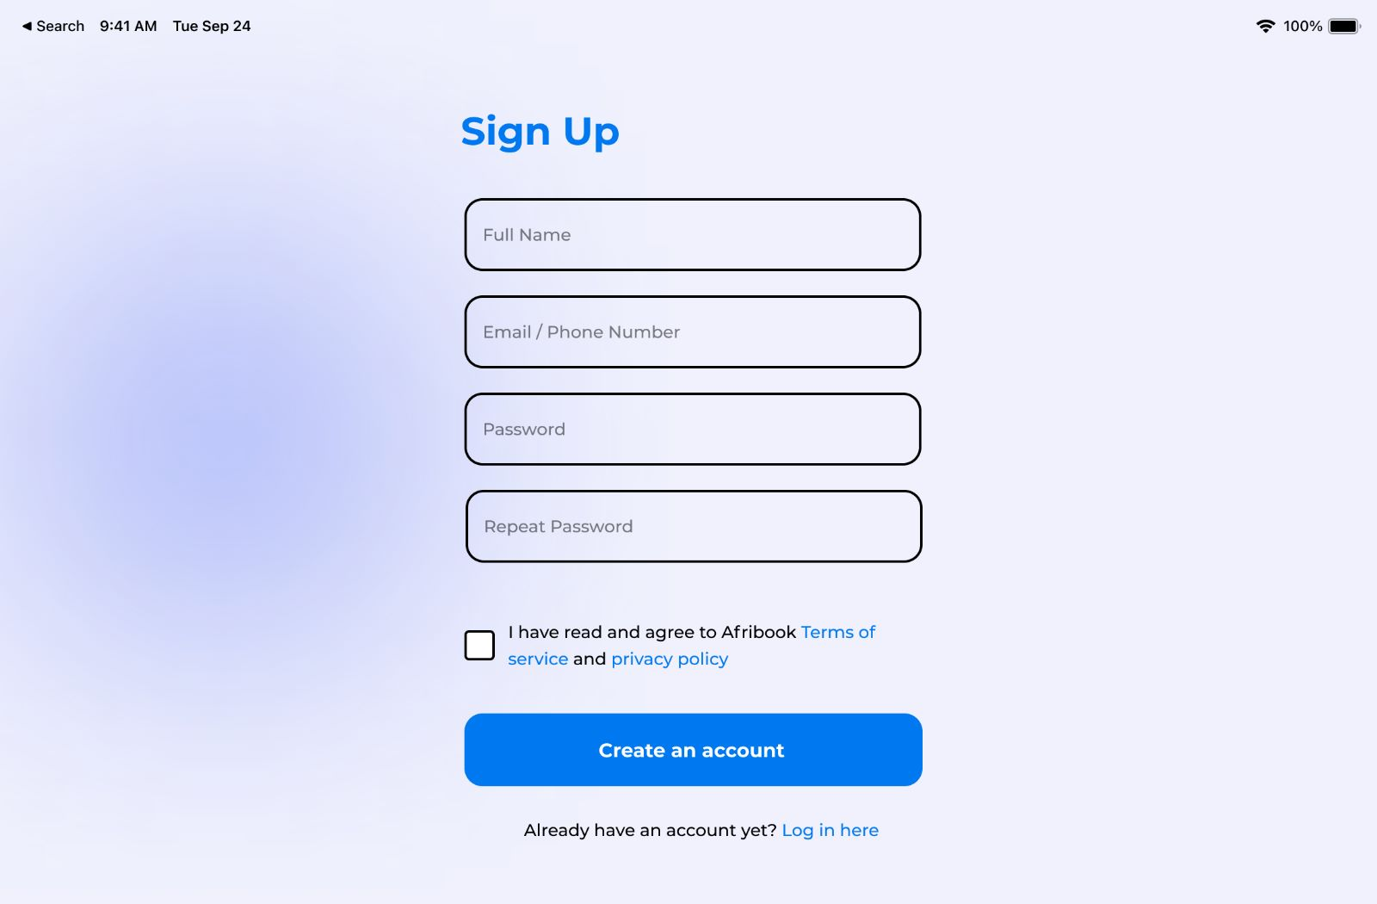The first page as shown above is the landing page.

The second page shows where the NHS staff can sign up.

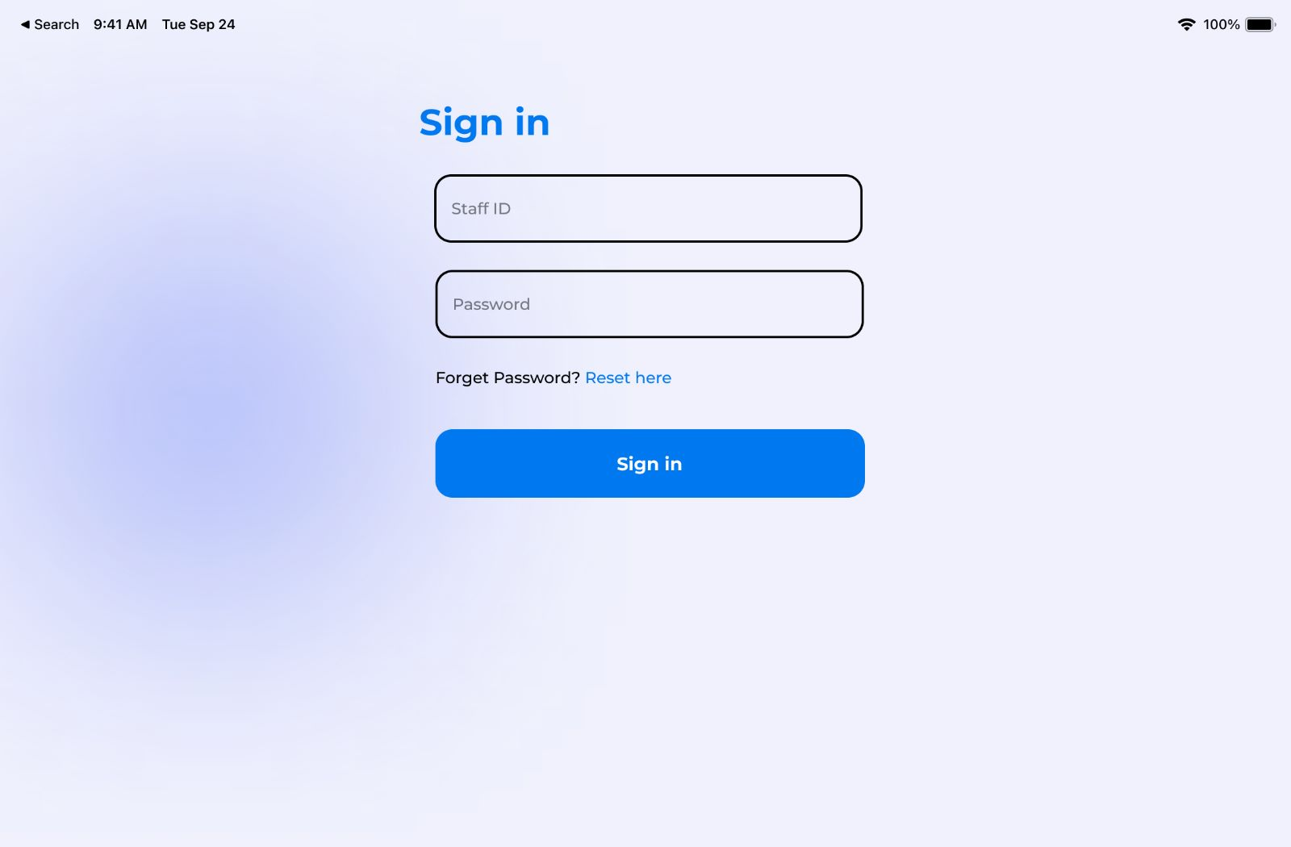

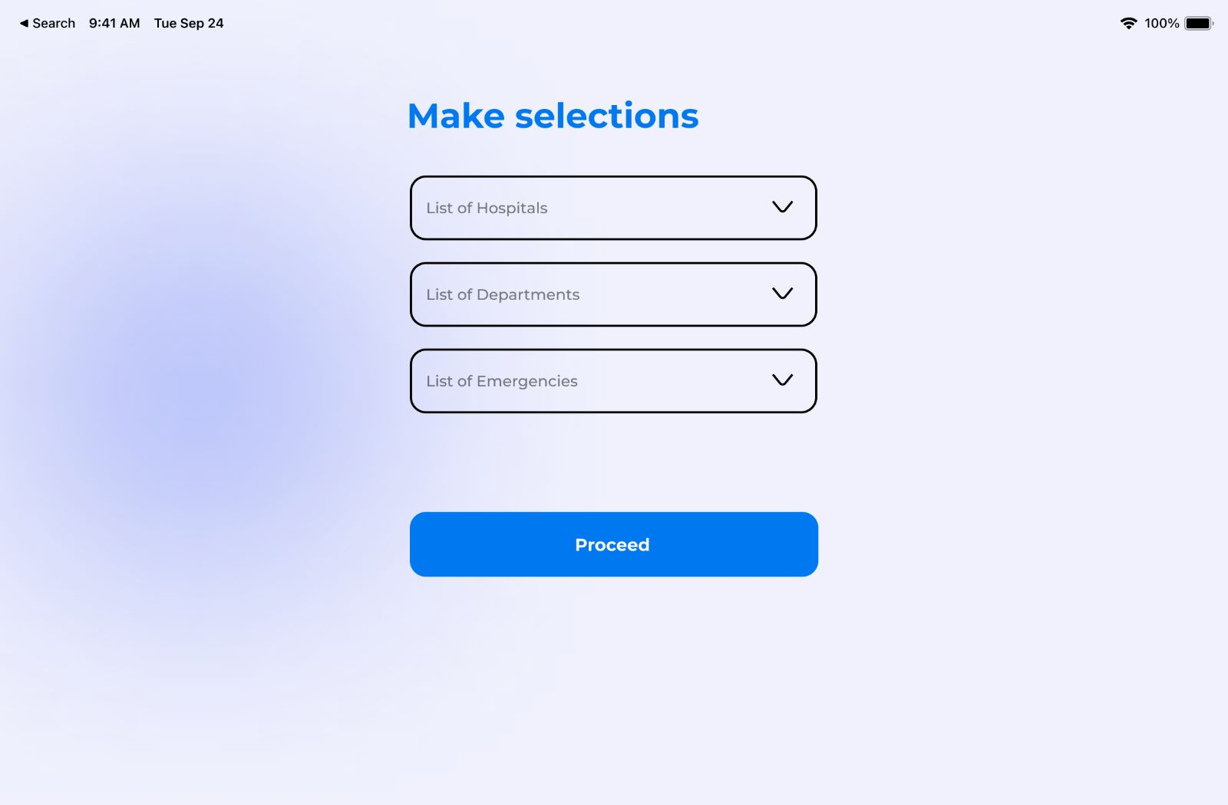The second page is the sign in page for new users to register

This page shows where users can select the hospital, department (A& E) and the type of emergency.

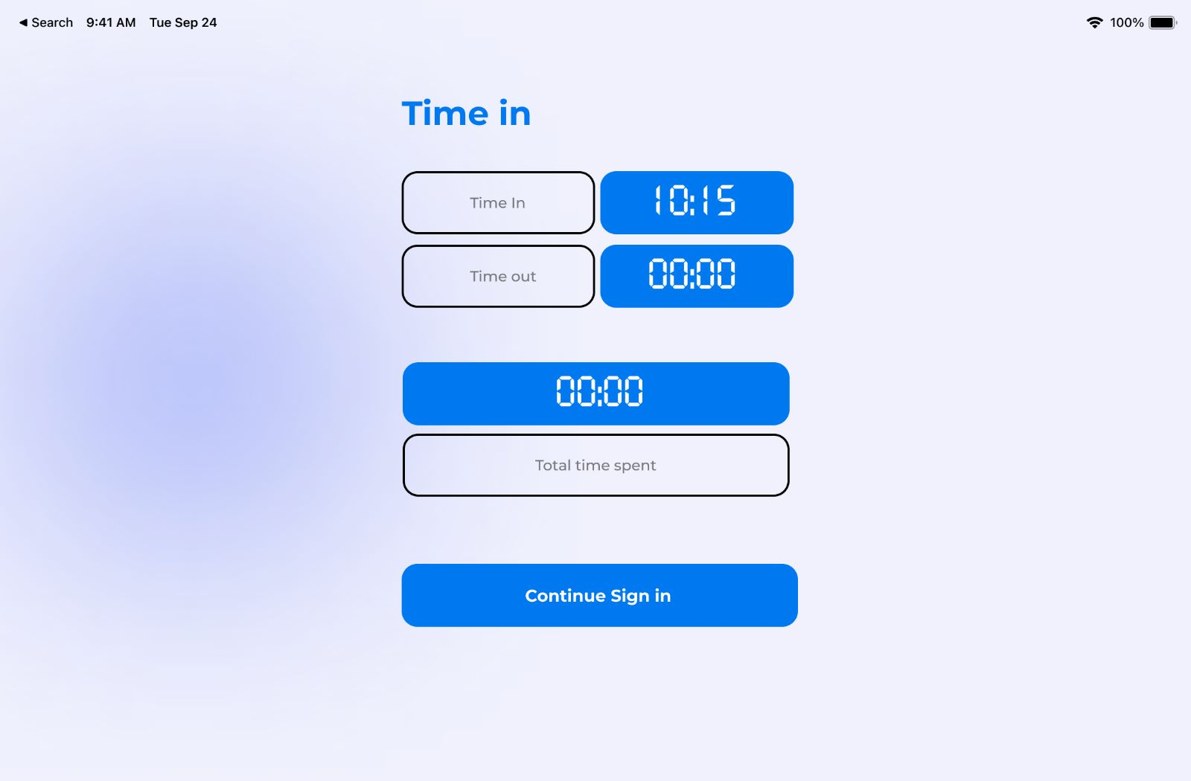

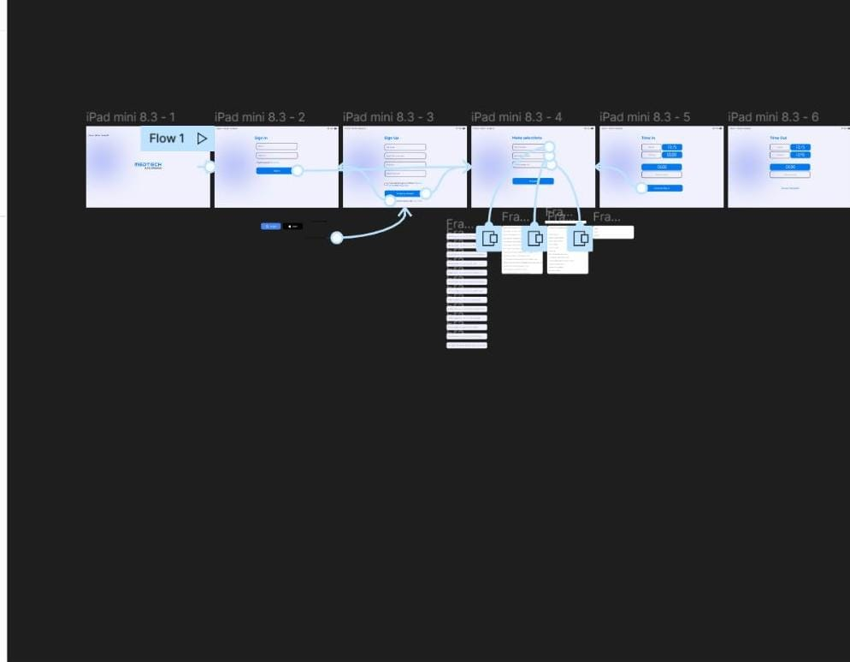From the moment of log in a specific code is generate for each emergency and this page shows the time in and time out of each emergency.

**Presentation –**

I made this presentation on behalf of my team. The prepared presentation video is given below:



**REFERENCE**:

* A&E Attendances and Emergency Admissions. Available from: https://www.england.nhs.uk/statistics/statistical-work-areas/ae-waiting-times-and-activity/
* Garcia, M. L., Centeno, M. A., Rivera, C., & DeCario, N. (1995). Reducing time in an emergency room via a fast-track. In Proceedings of the 27th conference on Winter simulation. pp. 1048-1053.
* Jun, J. B., Jacobson, S. H., & Swisher, J. R. (1999). Application of discrete-event simulation in health care clinics: A survey. Journal of the operational research society. 50(2), pp.109-123.
* Law, A. M., & McComas, M. G. (2000). Simulation-based optimization. In 2000, Winter Simulation Conference Proceedings. pp. 46-49.
* Kaukiainen, M., Spring, E., & Wåg, E. (1986). A simulator model of a Department of Diagnostic Radiology. Acta Radiologica. Diagnosis. 27(1), pp.71-75.
* McGuire, F. 1998. Simulation in Healthcare, Handbook of Simulation, edited by Banks, J., pp.605 – 627.
* Miller, M. J., Ferrin, D. M., & Messer, M. G. (2004). Fixing the emergency department: A transformational journey with EDSIM. In Proceedings of the 2004 Winter Simulation Conference. 2004 (2), pp. 1988-1993.
* Pitt, M. (1997). A generalised simulation system to support strategic resource planning in healthcare. In *Proceedings of the 29th conference on Winter simulation*. pp. 1155-1162.